|  |
| --- |
|  |
| Assignment 3 |
| Network Security (UCS727) |

|  |
| --- |
|  |

*Name:*  Sachleen Singh Chani

*Roll No.:* 101506143

*Date:* May 2021

## Q1. Write a program to implement the autokey cipher taking user input for the plain text and key.

### Answer:

**Code –**

# autokey cipher

#dictionary to store alphabets

dic **=** "abcdefghijklmnopqrstuvwxyz "

#modulo value to keep the values in the range of the alphabets

MAX_MOD **=** **len(**dic**)**

#function to get the input key

**def** getKey**():**

**print(**"\nEnter the key:"**)**

**return** **input().**lower**()**

#fucntion to get the input plain text

**def** getPlain**():**

**print(**"\nEnter the plain text:"**)**

#return after changing the string to lower case

**return** **input().**lower**()**

#enciphering function

**def** enCode**(**plain**,** key**):**

**print(**"\n---Started enciphering---"**)**

cipher **=** ""

**for** i **in** **range(len(**plain**)):**

#append the plain kext after the key and add to the plain text

**if** **(**i **<** **len(**key**)):**

cipher **+=** dic**[(** dic**.**find**(**plain**[**i**])** **+** dic**.**find**(**key**[**i**])** **)** **%** MAX_MOD**]**

**else:**

#plain text appended

cipher **+=** dic**[(** dic**.**find**(**plain**[**i**])** **+** dic**.**find**(**plain**[**i**-len(**key**)])** **)** **%** MAX_MOD**]**

**print(**"\n---Ended eniphering---\n"**)**

**return** cipher**.**upper**()**

#decipher fucntion

**def** deCode**(**cipher**,** key**):**

**print(**"\n---Started deciphering---\n"**)**

cipher **=** cipher**.**lower**()**

decipher **=** ""

**for** i **in** **range(len(**cipher**)):**

#appends the cipher text to the key and subtracts the value

#modulo keeps in the range of the dictionary

**if(**i **<** **len(**key**)):**

decipher **+=** dic**[(** dic**.**find**(**cipher**[**i**])** **-** dic**.**find**(**key**[**i**])** **)** **%** MAX_MOD**]**

**else:**

decipher **+=** dic**[(** dic**.**find**(**cipher**[**i**])** **-** dic**.**find**(**decipher**[**i**-len(**key**)])** **)** **%** MAX_MOD**]**

**print(**"\n---Ended deciphering---\n"**)**

**return** decipher

#gets user inputs for plain text and key

plain **=** getPlain**()**

key **=** getKey**()**

cipher **=** enCode**(**plain**,** key**)**

**print(**"The cipher text is:"**)**

**print(**cipher**)**

decipher **=** deCode**(**cipher**,** key**)**

**print(**"The deciphered/plain text is:"**)**

**print(**decipher**,**"\n"**)**

**Result –**

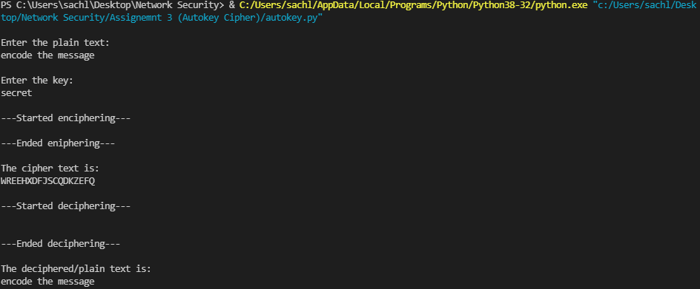

Figure Result for autokey cipher